Name_______________________________ Due Date: 11/8/2019
Partner_____________________________
ECOSYSTEM PROJECT

Directions: With your partner, create an illustration that demonstrates the interactions between organisms in an ecosystem through pictures and words. You should include a 6-8 sentence paragraph that explains interactions in your ecosystem, including interactions between producers and consumers and biotic and abiotic factors. Your finished project, including the paragraph, must presented on 18”x12” paper (provided by you teacher).

Examples:
Deciduous Forest
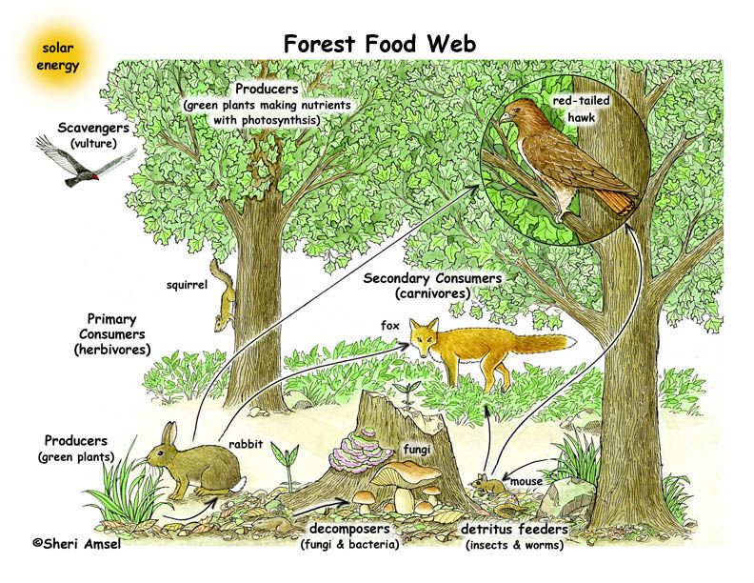 | Deciduous forests contain many types of trees; for example maple trees, beech trees and oak trees. Other producers that live in these forests are mosses, grasses and shrubs. The trees provide shelter for animals like birds, and squirrels, and dead trees provide habitat for decomposers. Two main categories of decomposers are fungi, for example mushrooms, and insects, such as pill bugs. Many herbivores, including deer and rabbits live in deciduous forests. These herbivores may be prey for carnivores like foxes and owls. The reason that so many species live in the deciduous forest, is because this climate has enough water and sunlight to support many producers, which provide for consumers and decomposers.
Arctic Tundra  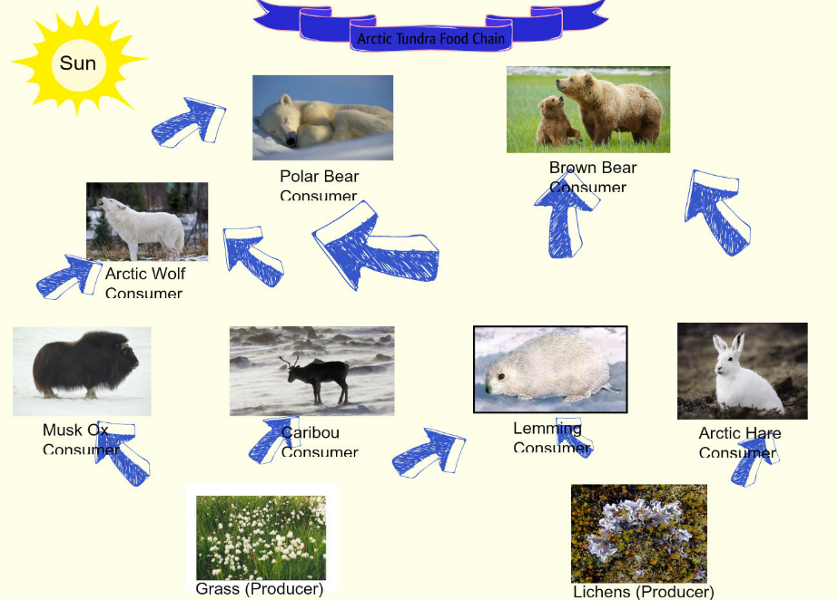 | Ecosystem  In the arctic tundra, there are no trees. The main producers are grasses and lichens. These plants use energy from the sun, through the process of photosynthesis, to grow and reproduce. Herbivores such as caribou, musk ox and arctic hares eat the grass and lichen. These animals are eaten by carnivores, like polar bears, and arctic wolves. Fish from lakes, rivers, and the ocean are also an important food source for many of these predators. Because the tundra is cold and there is little sunlight in winter, there are fewer producers than in warmer climates. This results in fewer consumers, and animals migrating with the seasons to find food.

Name______________________________________

Key Vocabulary
Ecosystem
Community
Population
Species
Abiotic
Biotic
Biome
Predator
Prey
Symbiosis
Mutualism
Commensalism
Parasite
Omnivore
Herbivore
Carnivore

1. What abiotic factors determine the number and type of producers?
______________________________________________________________________________________________
2. What is one example of a food chain that exists in your ecosystem?

3.What factors are most important in an ecosystem?
_______________________________________________________________________________________________

Abiotic Factors (water, sunlight)

Herbivores
Omnivores
Carnivores
Biotic Factors (plants, animals)

Decomposers
Consumers

Producers

Ecosystem:
____________________________________

